UCONN Avery Point Campus – LWB/Marine Sciences Bldg Directions and Parking

We will meet in Room 103 of the Marine Sciences Building, also known as the Lowell P. Weicker Jr. Building (LWB Building on the Campus map)
- Room 103 is on the end of the building closest to Long Island Sound (see red star in map below).

We ask that participants park in Area/Zone 2 = Lot B or Lot D (see map below). This will be a ~10 mins walk to LWB. https://averypoint.uconn.edu/about/directions-and-parking/
- Vistor parking typically costs $6/day. This parking fee can be waived by entering your license plate in a PayByPhone app (or use the parking event link sent in advance by CT NERR staff).
- Handicapped parking is immediately adjacent to the LWB building (<30 feet away), on the east side of LWB – drive past Project Oceanology, towards the waterfront; note, this parking area is not labeled on the map. Additional handicapped parking is available in the Visitor Parking area.
- UConn employees may park in any space in Lot D.

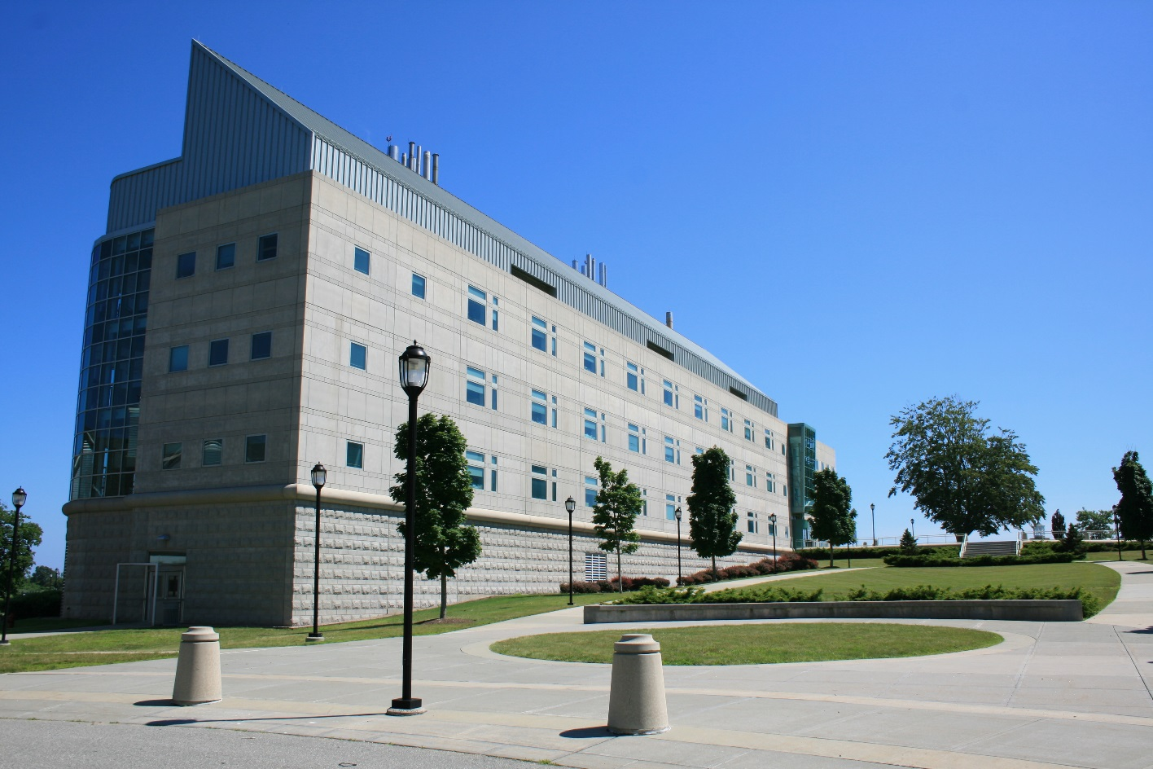

Lowell P. Weicker Jr. Building (LWB) Marine Science Building photo
See a parking map & driving directions on pages that follow.

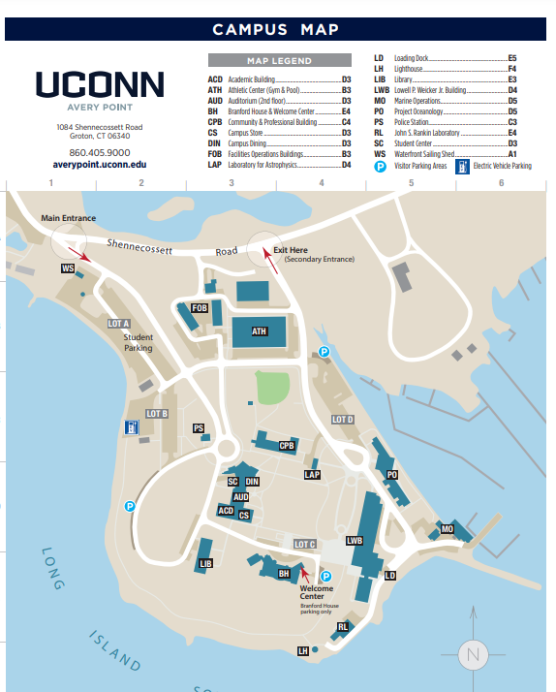
Branford House
LWB, Room 103
Visitor Parking Lot B
Visitor Parking Lot D
Project Oceanology

Driving Directions

University of Connecticut Avery Point Campus
1080 Shennecossett Rd
Groton, CT 06340
From the east (Providence, Boston) – Take I-95 S to exit 87 (left side exit), Clarence B. Sharp Hwy/CT-349 toward US-1 (1.9 mi). At the second set of stoplights take a right (you will see a sign here for the University of Connecticut at Avery Point). At the next corner and set of lights, take a left. Follow this road for several miles, straight, past Pfizer and the Shennecossett Golf Course. Shortly after the golf course you will come to the entrance on the right side for the University (big blue sign) just before a sharp curve.
From the west (New Haven, New York) – Take I-95 N to exit 87 Clarence B. Sharp Hwy/CT-349 toward US-1 (1.9 mi). At the second set of stoplights take a right (you will see a sign here for the University of Connecticut at Avery Point). At the next corner and set of lights, take a left. Follow this road for several miles, straight, past Pfizer and the Shennecossett Golf Course. Shortly after the golf course you will come to the entrance on the right side for the University (big blue sign) just before a sharp curve.
From the north (Norwich, Worcester) – Take I-395 S to exit 78 (left side exit) toward CT-32/New London (0.4 mi). Merge onto Montville Connector (0.9 mi). Slight right at CT-32/Mohegan Avenue Parkway; continue to follow CT-32 (3.3 mi). Merge onto I-95 N/US-1 N via the ramp to Providence/Groton (1.7 mi). Take exit 87 Clarence B. Sharp Hwy/CT-349 toward US-1 (1.9 mi). At the second set of stoplights take a right (you will see a sign here for the University of Connecticut at Avery Point). At the next corner and set of lights, take a left. Follow this road for several miles, straight, past Pfizer and the Shennecossett Golf Course. Shortly after the golf course you will come to the entrance on the right side for the University (big blue sign) just before a sharp curve.

